Starting for the first time

Downloading the App (Optional)
There are apps available for most platforms including:
- Windows
- Mac
- iPad
- iPhone
- Android
- And others…
There is no need to download the app, but it may make it easier in the long run.

Go to the appropriate App store and search for Zoom. Choose the right one, as there are quite a few variants! The logo looks like this:

How To Start the session
Use the link directly from the email. This will have some key information for you. The email may have information that looks like
WSQ Conference is inviting you to a scheduled Zoom meeting.
Join Zoom Meeting
https://zoom.us/j/764589709?pwd=SHV2NHJhQVlLb3hEd2NYUXhRYyt6dz09
Meeting ID: 764 589 709
Password: 019656
One tap mobile
+61370182005,,764589709#,,#,019656# Australia
+61731853730,,764589709#,,#,019656# Australia
Dial by your location
+61 731 853 730 Australia
Meeting ID: 764 589 709
Password: 019656
Find your local number: https://zoom.us/u/acXquf1djB
The easiest method is to click on the link, or copy it into your browser. It will take you there automatically and will prompt you to choose to use the browser or the installed Zoom app (if you have it).
I have the Windows App installed and have signed into the Zoom account we have. It notifies me of the upcoming scheduled meetings, and gives me the option of starting or scheduling some more:
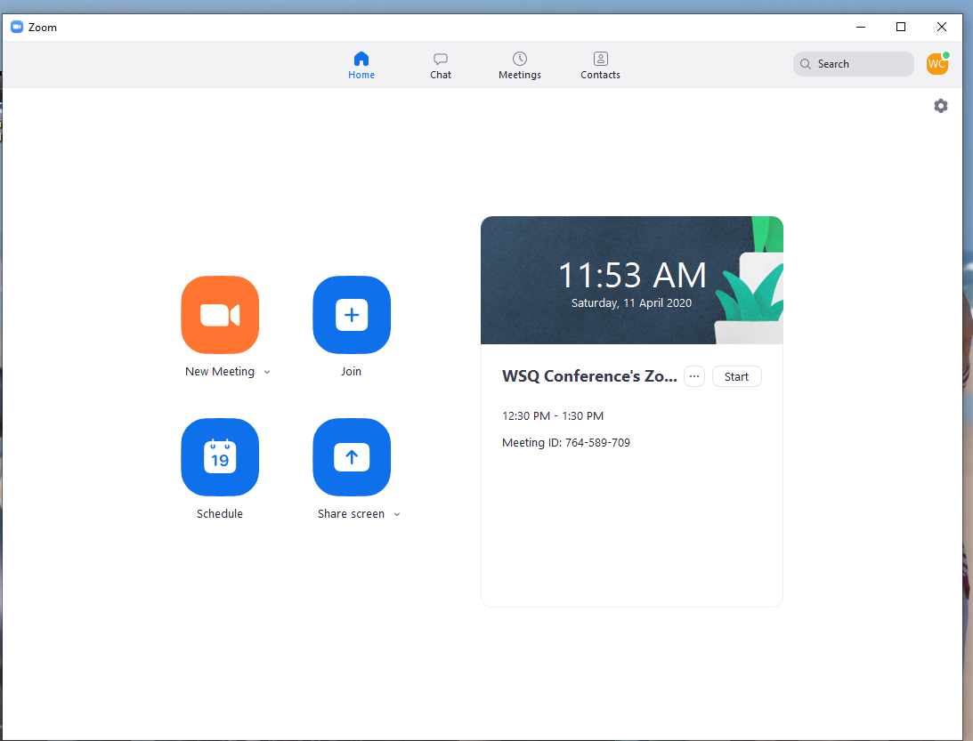
In the Meeting ID, use the number from the email (Meeting ID: 764 589 709) without spaces…
Please use your name (in the screenshot below, I am signed in as the WSQ Conference ID), preferably in full to allow other participants to see who you are.
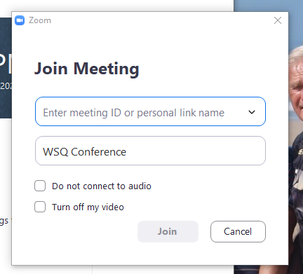
Once you open a meeting, you will see names/pictures of people already on the call, plus the host. It will look a little more crowded than this (my apologies to Brian and Ian here):
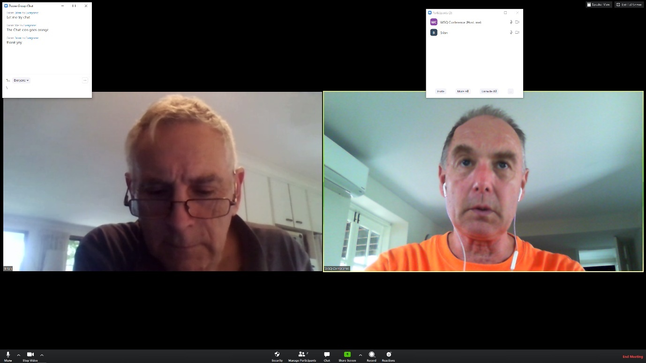

Using the elements on the screen:
Once you have joined the meeting, you will have a few options to play with. Please look around as we have noticed that in different versions the sequence is different, and the name may be slightly altered. The main functions are the same! In all cases the little up arrow (caret ^) will pop open a menu of choices.
IPAD: To get these menus visible on an iPad, tap your video picture, and you will see the options displayed around the screen.
WINDOWS: On the left in Windows, you have

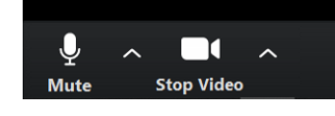
In the centre you will see a subset of these (I am host in this screen shot):
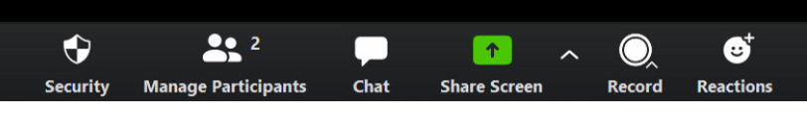
On the far right, I Have:

At the top of the screen, you MAY have the participants list showing (press the Manage Participants to show/hide)
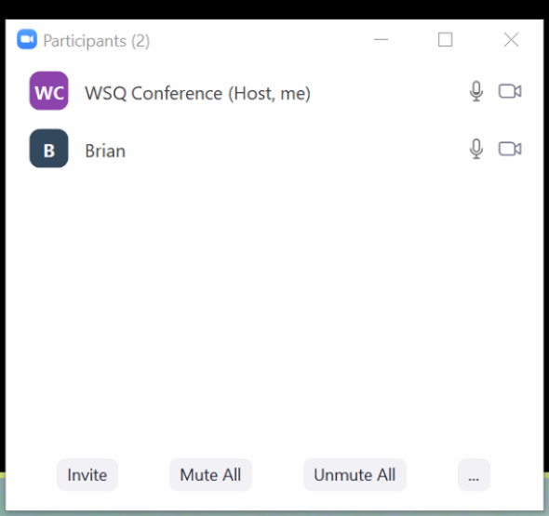

Audio
You can mute and un-mute using the left most icon. Other Audio controls include volume and muting. You may have the option to use different devices, so select the best one for this occasion.

Video
You can opt to switch off your video (or switch it back on). Using the ^ next to the Video icon, you can select from the options. I get to choose
- my camera (front/back)
- Switch off the camera
- Select my background (to make it look like you are elsewhere – beware it can have odd results)
- Settings (in case I can change my camera settings)
If you have a tablet or phone, you can go on a guided tour of your workshop. Switch to front camera and go for a walk – but be careful of your step, we don’t want to have accidents.

Chat
Chat is like the phone messages. Leave a message for the whole audience or a specific member. Try to avoid side conversations, but it can be useful if you need help. It is great for little asides, but use it sparingly to reduce distracting everyone.
You can move the chat window around to somewhere convenient or hide it. To reshow it, press the Chat icon as you did earlier.

Screenshare
On some occasions, it will be useful to see what is on your machine. Examples are a video or picture gallery. You can share the screen/app, and everyone else will be able to see that screen.
Make sure you have nothing unwanted displayed (passwords, emails, …) as we see it all!

Reactions
You can virtually applaud or indicate a thumb up, by using the Reactions options. You may have an option to put up your hand, which will indicate to the host that you have a question or comment and would like to speak. This is a great way to record your request without interrupting the presentation. The presenter can then pause and take questions at a sensible point.

Using the iPad Application
Start the App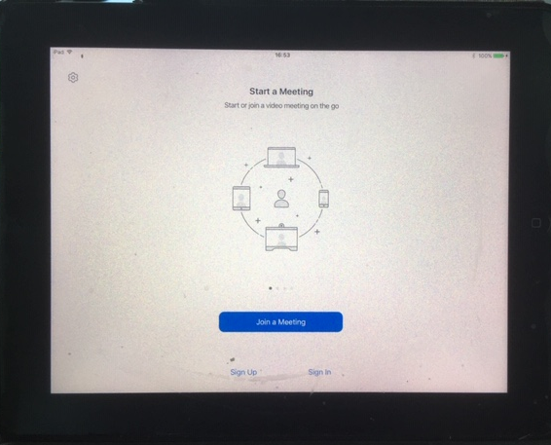
Then enter the details as before:
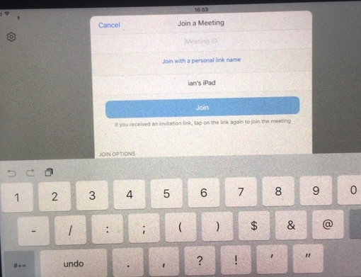
Enter the Meeting ID and amend the link name to be your First and Last name, then click Join
Once in the meeting, you can tap the screen, along the bottom of the screen you get
- mute,
- stop video,
- participants (for invite and chat)
- or the ellipsis (…) more. Options include the thumbs up, clap, chat, settings and raise hand. Share allows you to choose content on your phone,
At the top of the screen you can choose the camera (front/rear|) if you have them. Leave is in the top right… in red.

Using the Phone App (iPhone and Android)
Start the App, then click Join a meeting:
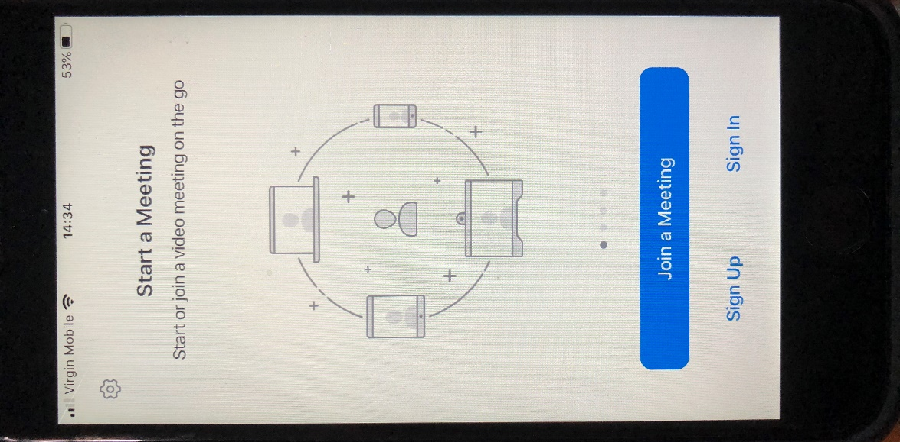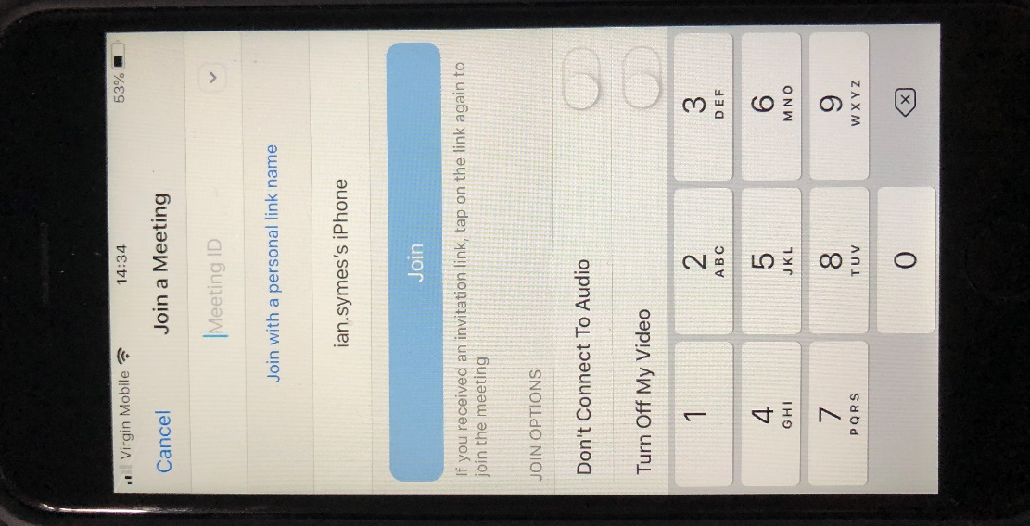
Enter the Meeting ID and amend the link name to be your First and Last name, then click Join
Once in the meeting, you can tap the screen, along the bottom of the screen you get
- mute,
- stop video,
- participants (for invite and chat)
- or the ellipsis (…) more. Options include the thumbs up, clap, chat, settings and raise hand. Share allows you to choose content on your phone,
At the top of the screen you can choose the camera (front/rear|) if you have them. Leave is in the top right… in red.

General Guidelines

Position the camera and screen
To make sure that you can be seen clearly on video, try and keep your face in even light. Avoid windows behind you, as the camera then struggles to expose your face without lots of shadow.
If you are setting up a video to share, ensure that the sound balance is reasonable and that the camera work is not too quick – there may be a delay between the video you are displaying and the other people viewing it over zoom.

Using a Headset and microphone
Background sounds are picked up by PC microphones very easily. On a call like these, they often get magnified, and with many people on the call it becomes difficult to hear properly. There are two approaches to resolving this:
- Mute your microphone when not talking (just remember to unmute when you want to talk!)
- Use a headset or headphones. My preferred headset comes with my phone and has a microphone incorporated. Whilst not mandatory, they often reduce the ‘tinny’ sound that others hear when using the on-PC microphone.

Meeting Protocol
Please be prepared and be succinct when you are talking. The moderator/host will try and make sure that everyone gets their fair time. Let the host know if you want to speak, and let them find a good spot to interrupt. (Try using the “Raise Hand” option).
If you are just listening, put yourself on mute and listen without background interference. If you need to duck out, then don’t leave your microphone and video on, as it could be embarrassing … just let the host know.

